There are multiple ways to access the marital information for your borrower. In this aide we are accessing it through the contact screen. You can also access the screen from pricing summary and/or VA NTB screen.

In the loan go to the Contact Information screen and click on the married couple as indicated below located on the top of the page
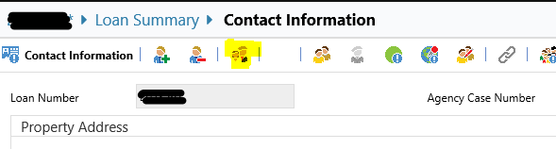
It does not default to showing as married. Click the drop down and select the spouse from the drop down to ensure your Funding Fee is calculated correctly and not split and avoid a tolerance cure.
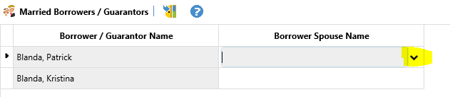
It should look like the image below
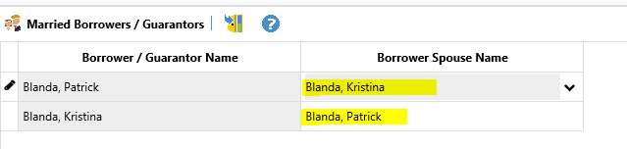

The next step is to go to the Loan Calculations screen, click on Funding Fee tab, and click the calculator button to enter in the appropriate Funding Fee.
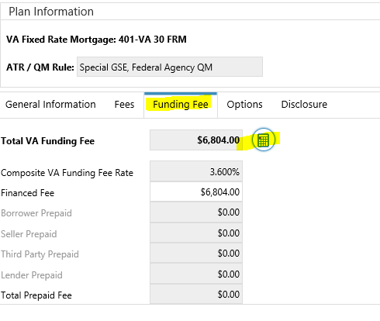
The Veteran should be listed as borrower #1. You confirm your loan type since Funding Fee’s will be different depending on loan types and LTV’s. Confirm if client is exempt or not and if it is their first time use or subsequent use.
