In Section IV of the 1003 verify whether the borrower is a W2 employee, Self Employed, or Retired.
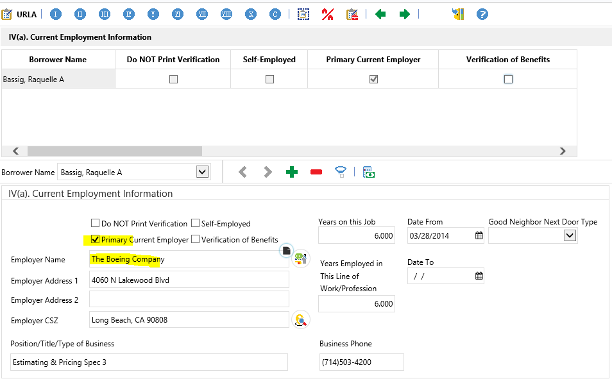
If borrower is a W2 employee, utilize the link below to confirm if their employer is on the work #.
Tip: Keep the search simple with the main name of the company
https://secure.theworknumber.com/popups/findEmployer.aspx
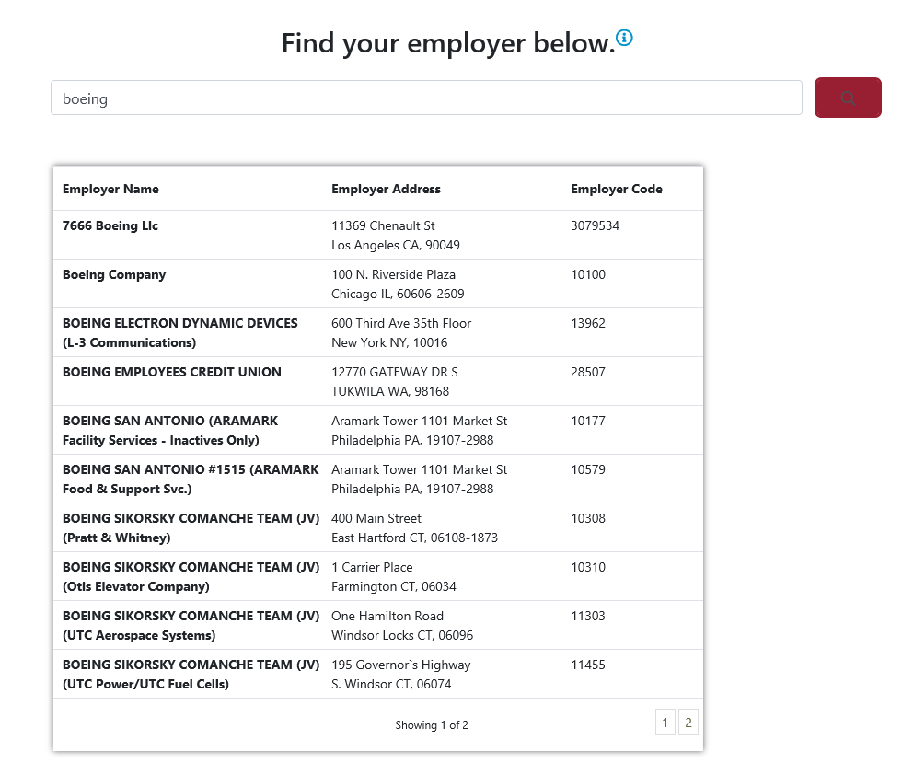

In this example the employer is on the work #, the next step is to go back to the 1003 and update the employer name to match what is on the work # lookup.
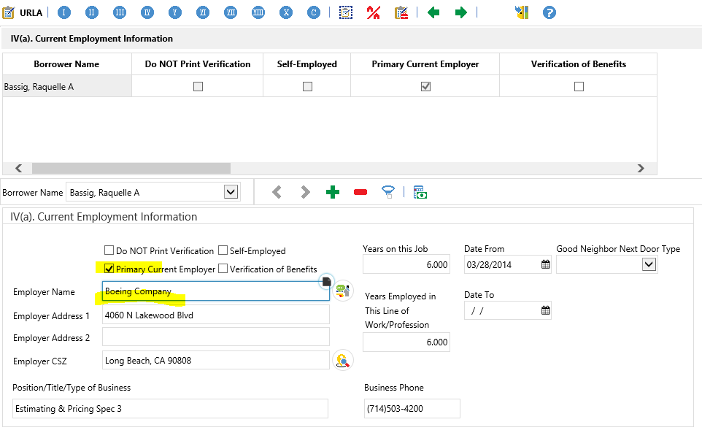
Once system is updated, go to Services tab and click on LoanSphere Verifications to order the VOE in the system.
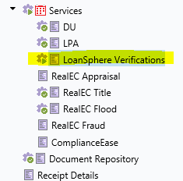

Below is what will appears in the screen, the tabs will all be open. The steps taken on the following page will ensure the ability to get the VOE back through the system.
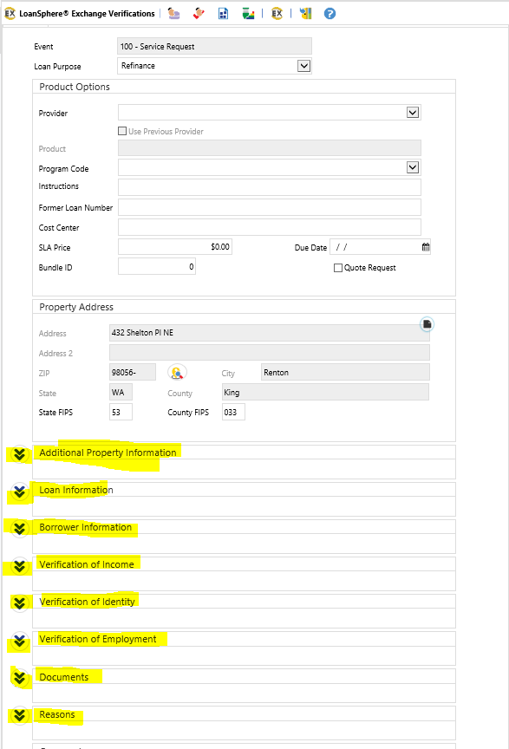
1.Provider is PRD Equifax Verification – VOE/VOI and the Product is Employment Only Verification
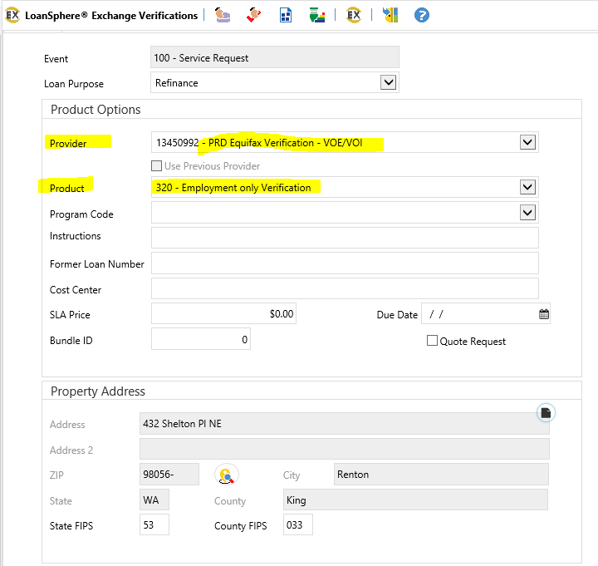
2. In the Additional Property Information, fill in the Type, Occupancy, and Contact Type. It is okay to choose this Primary Borrower even if the VOE you are pulling is on the Co-Borrower.
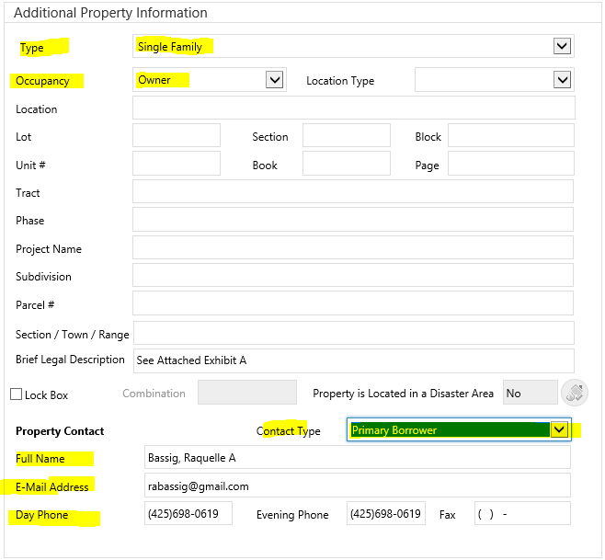

3. Under the Loan Information section choose the contact type. Under borrower information section choose the borrowers to the transaction
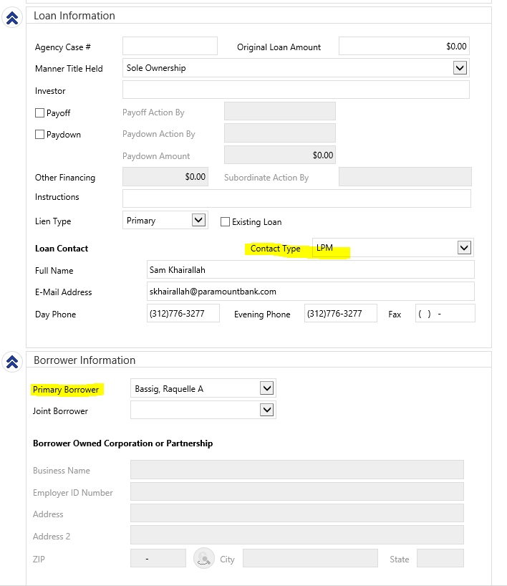

4. Verification of Income and Verification of Identity will be left blank. In the Verification of Employment section, select the Borrower’s name that the VOE is for and choose the Employer name in the drop down, you will then select “Written” in the Verification Type. Once completed click the square box with the arrow pointing down to have the employer information fill in as shown below.
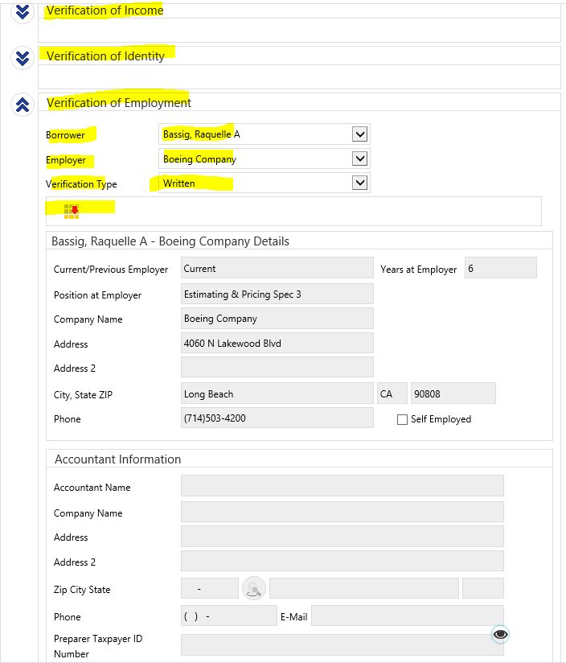
5. In the Documents section click the arrows and then click the plus sign to add in the borrower’s authorization form from the Doc Repository. Please note that if the borrower authorization is not uploaded in the Doc Repository the VOE cannot be ordered. In the description box choose Borrower Authorization from the drop down in Doc Type. The reasons section can be left blank

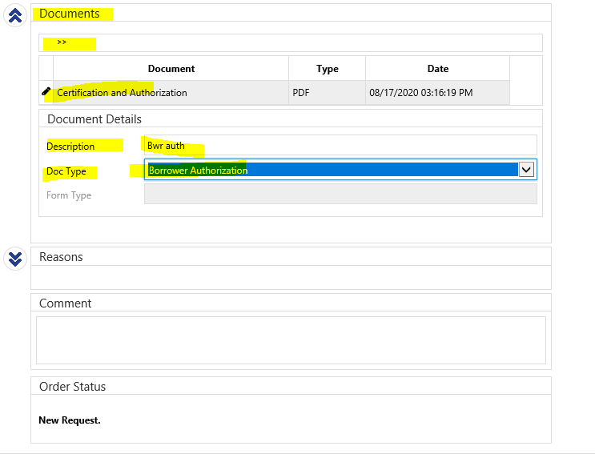

6. Once borrower authorization is added, click the Submit Request button. If validation is clicked, go back through the page again and ensure the system is filled out (it will delete out the Verification of Employment section).

7. Once Completed go to the Doc Repository and search for the LoanSphere Exchange Verification Output Document. This is where the VOE will be. Make sure to update the start date, company name, and job title in section IV and V of the 1003 to match information on the VOE. Check income calculations per the VOE.
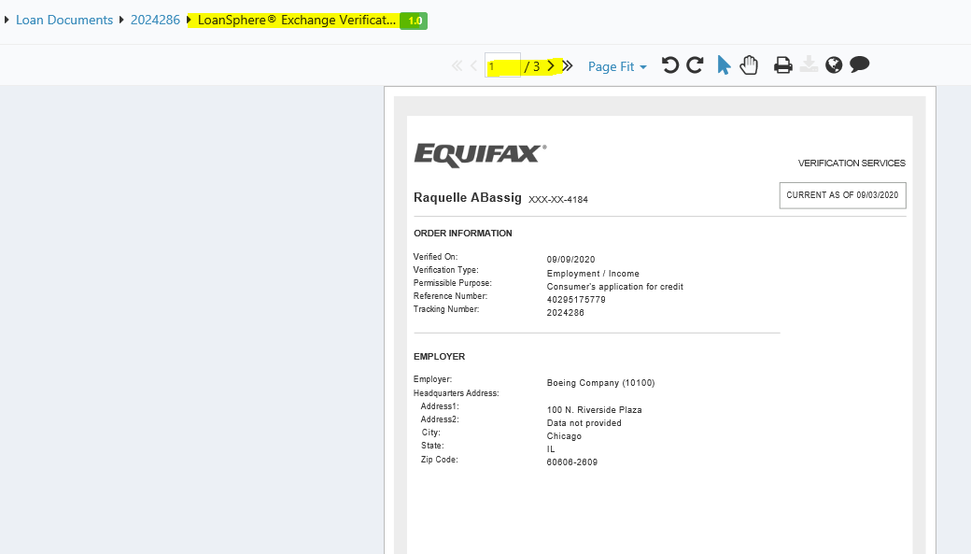

If VOE is pulled from the work # directly, follow these steps:
Type in the client’s SSN and fill out the tracking # with the loan #. Choose Employment & Income under Verification Type(s). Please note if the loan # is not in the tracking section, the AUS will not read the VOE and Day 1 Certainty will not run.

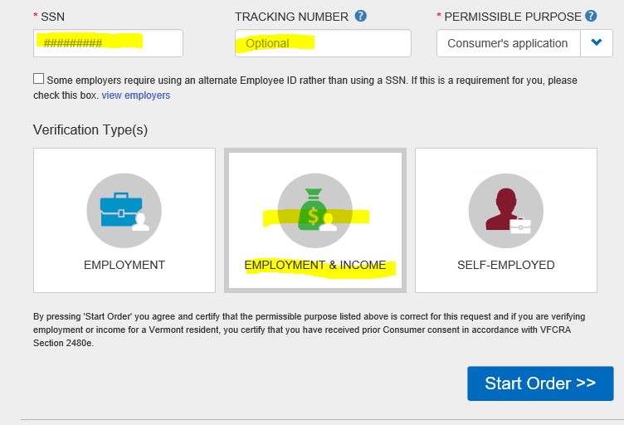
Consent should be marked as Yes. Go to the Standard VOI section and choose Current Employers. DO NOT choose any other options as the price of the VOE is either double or triple the normal price. Once filled out click next t and the VOE will pull up on the next screen.
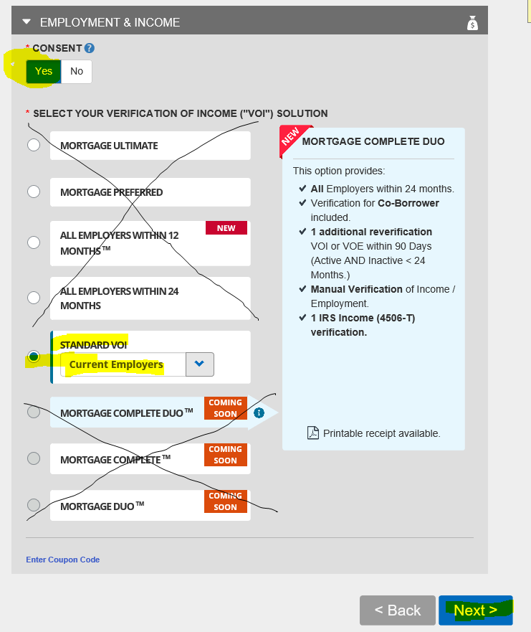
Below is how the DU Findings will read (in the employment section). In the example below AUS #13 & 14 show that the only document needed is a verbal VOE and a signed 4506t. AUS #17 shows the validated income that must be used in section V of the 1003. Please note, if the loan does not close by date indicated, a new VOE will need to be ordered. You will need to run a new AUS to update the date.
Please note: AUS will indicate if it could not validate the income. Examples include income that may have decreased, less than 12 months at current employer, or the YTD income is inconsistent with hourly rate/earnings stated on the VOE.

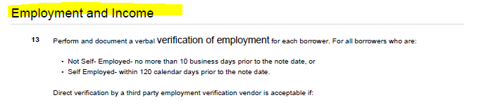
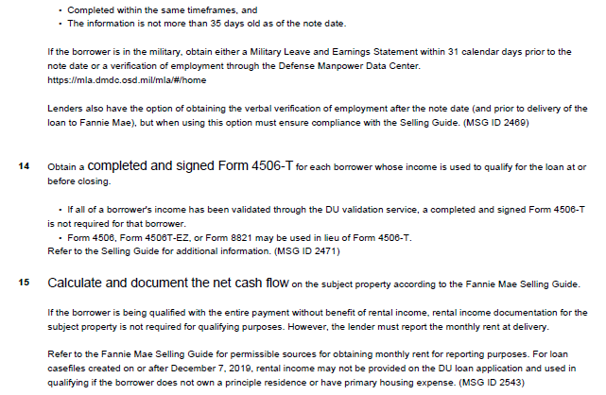

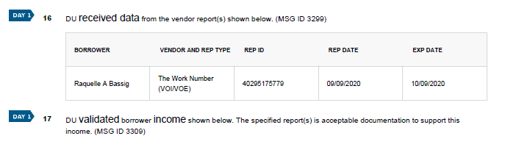
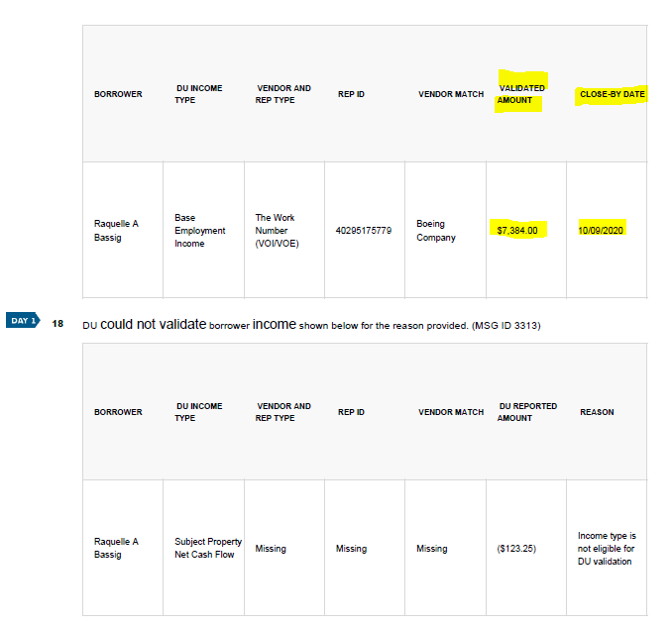

For LP employment section of the findings will simply indicate what income must be used to qualify and when it expires.

